Specification of software requirements

Subject: Web information system for technology sales of the company Super Tech.

 |  | August 2022

Date | Review | Description | Author
10/08/2022 |  |  | Coyago Eunice  Cueva Wendy  Cunguan David  Fonseca Armando

Document validated by the parties on:

For the company | For the University
SUPER TECH  Always Innovating for The Reach of Your Pocket | Universidad de las Fuerzas Armadas - ESPE

Content
Content 3
1 Introduction 5
1.1 Purpose 5
1.2 Scope 5
1.3 Involved personnel 5
1.4 Definitions, acronyms, and abbreviations 6
1.5 References 7
1.6 Summary 7
2 General description 7
2.1 Product perspective 7
2.2 Product functionality 8
2.3 User characteristics 8
2.4 Restrictions 9
2.5 Assumptions and dependencies 9
3 Specific requirements 9
3.1 Functional requirements 9
3.2 Non-functional Requirements 12
3.1 Common interface requirements 15
3.1.1 User interfaces 15
3.1.2 Hardware interfaces 15
3.1.3 Software interfaces 16
3.1.4 Communication interfaces 16
3.2 Functional requirements 16
3.2.1 Functional requirement 1 16
3.2.2 Functional requirement 2 16
3.2.3 Functional requirement 3 16
3.2.4 Functional requirement 4 16
3.2.5 Functional requirement 5 16
3.3 Non-functional requirements 17
3.3.1 Performance requirements 17
3.3.2 Security 17
3.3.3 Reliability 17
3.3.4 Availability 17
3.3.5 Maintainability 17
3.3.6 Portability 17

Introduction
Before the pandemic, businesses made little use of virtual platforms. However, after the pandemic, everything was virtualized, both the delivery system and the orders took a turn, but when placing orders, problems arose such as registration or ghost shipping of, or businesses not having a delivery service.
That is why we see the need to develop a system that manages the available products in stock with basic movements such as login, adding a product to the cart, in addition to verifying whether the user is registered or not.

Purpose
Once the problem has been identified, the proposal to solve it is the development of a web application for managing the delivery of online technology products, using forms for their storage, thus allowing the use of an application as a contingency plan in case of store failure virtual.

Scope
The system will be able to manage the purchase of the products, verify if it is in stock, the quantity of products, including the necessary information so that the client is able to visualize what he needs. The user will create a profile, with which he will access the system together with the option to add to the cart and make the purchase or in case of canceling the added products.

Involved personnel

Name | Coyago Arce Eunice Pamela
Role | Designer and programmer
Professional category | IT engineering student
Responsibilities | Design and programming of the PRP
Contact information | epcoyago@espe.edu.ec

Name | Cueva Cangas Wendy Nicole
Role | Designer and programmer
Professional category | IT engineering student
Responsibilities | Design and programming of the PRP
Contact information | wncueva@espe.edu.ec

Name | Cunguan Guanopatin David Ernesto
Role | Designer and programmer
Professional category | IT engineering student
Responsibilities | Design and programming of the PRP
Contact information | decunguan@espe.edu.ec

Name | Fonseca Zurita Armando Rafael
Role | Designer and programmer
Professional category | IT engineering student
Responsibilities | Design and programming of the PRP
Contact information | Arfonseca1@espe.edu.ec

Definitions, acronyms, and abbreviations
Name | Description
User: | Person who will use the system to manage processes
SIS-I | Web information system for technology sales of the company Super Tech
RF | Functional Requirement
RNF | Non-functional requirement

References
Reference | Title | Route | Date | Author
IEEE | Standard IEEE 830 - 1998

Summary
This document consists of three sections. The first section introduces the document and provides an overview of the system resource specification. The second section of the document provides a general description of the system, to know the main functions to be performed, the associated data and the factors, constraints, assumptions and dependencies that affect the development, without going into excessive detail. Finally, the third section of the document defines in detail the requirements to be met by the system.

General description

Product perspective
The SIS-I system will be a product designed to work in WEB environments, which will allow it to be used quickly and efficiently. The first thing that the viewer will observe when entering the virtual store will be the products or services that are offered. The products that will appear on the web pages of our virtual store can be presented and managed in different ways. The simplest is using static web pages that are modified every
time some information about the product is altered. This approach is simple and valid for stores with few products that vary little in their characteristics and prices.

Product functionality
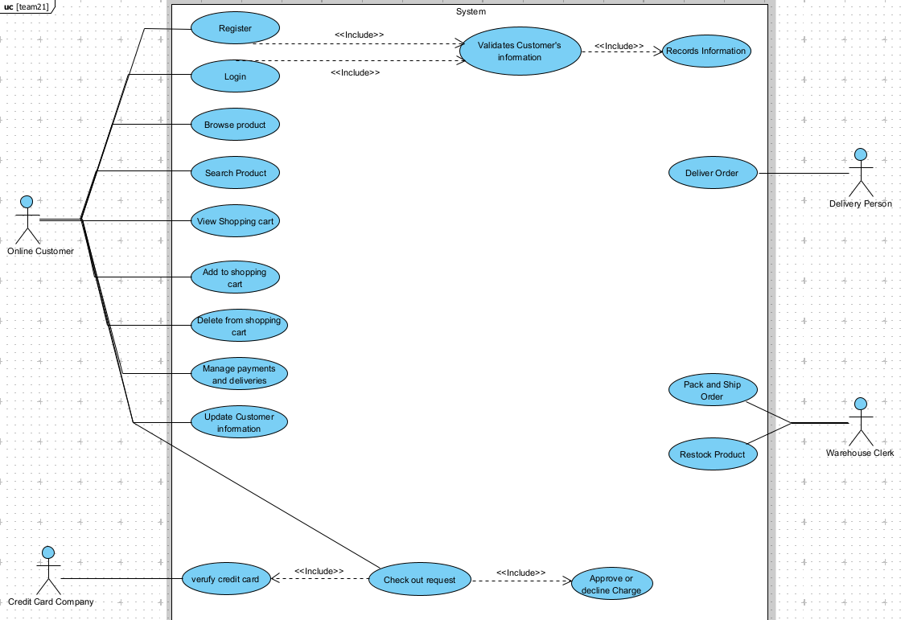

User characteristics

Type of user | Customer
Training | Basic technological knowledge
Activities | Enter information into the system

Type of user | User
Training | Basic technological knowledge
Activities | Active participation in the system

Type of user | Manager
Training | Basic technological knowledge
Activities | System administrator and active customer accounts

Restrictions
- Interface to be used with internet.
- Languages and technologies in use: HTML, JavaScript.
- The system shall be designed according to a client/server model.
- The system shall have a simple design and implementation, independent of platform or programming language.

Assumptions and dependencies
- The requirements described here are assumed to be stable.
- The equipment on which the system is to be run must meet the above requirements to ensure proper execution of the system.

Specific requirements

3.1 Functional requirements
Requirement number | RF01
Requirement name | User authentication
Characteristic | Users must identify themselves to access the system
Description of the requirement | The system can be consulted by any user depending on their level of accessibility
Requirement priority | High

Requirement number | RF02
Requirement name | User Registration
Characteristic | Users must log into the system to access any part of the system.
Description of the requirement | The system will allow the user (Client and Administrator) to register. The user must provide data such as: CI, First Name, Last Name, E-mail, User and Password.
Requirement priority | High

Requirement number | RF03
Requirement name | Consult Information.
Characteristic | The system displays general product information.
Description of the requirement | Consult Information: The system will provide the user with general information about the products in stock.
Requirement priority | High

Requirement number | RF04
Requirement name | Consult Information.
Characteristic | The system will be able to display the features and prices of each product.
Description of the requirement | Consult Products: Displays general information about the products along with their features and prices.
Requirement priority | High

Requirement number | RF05
Requirement name | Modify
Characteristic | The system will allow the administrator to modify personal data and products.
Description of the requirement | Allows the administrator to modify data of users, products and accounts created.
Requirement priority | High

Requirement number | RF06
Requirement name | Manage system
Characteristic | Allows information regarding the product or company.
Description of the requirement | Create Products: Allows the administrator, once logged into the system, to create a product and provide relevant information to customers, maintaining active communication.
Requirement priority | High

Requirement number | RF07
Requirement name | Manage system
Characteristic | Allows information regarding the product or company.
Description of the requirement | Register user: The user must provide his/her ID and name along with a password to access the system.
Requirement priority | High

Requirement number | RF08
Requirement name | Manage system
Characteristic | Allows information regarding the product or company.
Description of the requirement | Product: The customer must log in to generate payment for the products.
Requirement priority | High

Requirement number | RF09
Requirement name | Manage system
Characteristic | Allows information regarding the product or company.
Description of the requirement | Consult products: Allows users to view product information along with product features and prices.
Requirement priority | High

3.2 Non-functional Requirements

Requirement number | RF01
Requirement name | System interface.
Characteristic | The system will feature a simple user interface to make it easy for system users to operate.
Description of the requirement | The system must have an intuitive and simple user interface.
Requirement priority | High

Requirement number | RF02
Requirement name | Help in using the system.
Characteristic | The user interface should have a help system to facilitate the work of the system's users.
Description of the requirement | The interface must be complemented by a good help system (the administration may be carried out by personnel with little experience in the use of computer applications).
Requirement priority | High

Requirement number | RF03
Requirement name | Maintenance
Characteristic | The system shall have an installation manual and user manual to facilitate maintenance to be performed by the administrator.
Description of the requirement | The system must have easily updatable documentation that allows maintenance operations to be carried out with the least possible effort.
Requirement priority | High

Requirement number | RF04
Requirement name | Interface design to the web feature
Characteristic | The system must have a user interface, taking into account the characteristics of the company's website.
Description of the requirement | The user interface must conform to the characteristics of the company's web site, within which the sales management system will be incorporated.
Requirement priority | High

Requirement number | RF05
Requirement name | Performance
Characteristic | The system will guarantee users a performance in terms of the data stored in the system, offering reliability to the system.
Description of the requirement | Guarantee the performance of the computer system to the different users. In this sense, the information stored or records made may be consulted and updated permanently and simultaneously, without affecting the response time.
Requirement priority | High

Requirement number | RF06
Requirement name | User Level
Characteristic | Guarantee the user access to information according to the level he/she has.
Description of the requirement | Facilities and controls to allow access to information to authorized personnel through the Internet, with the intention of consulting and uploading relevant information for each of them.
Requirement priority | High

Requirement number | RF07
Requirement name | Continued system reliability
Characteristic | The system will have to be operational 24 hours a day, 7 days a week. Since it is a web page designed for data uploading and communication between users.
Description of the requirement | The availability of the system must be continuous with a service level for the users of 7 days per 24 hours, guaranteeing an adequate scheme that allows the possible failure in any of its components, to count on a contingency, generation of alarms.
Requirement priority | High

Requirement number | RF08
Requirement name | Information security
Characteristic | The system will guarantee the security of the information processed in the system to the users.
Description of the requirement | Facilities and controls to allow access to information to authorized personnel through the Internet, with the intention of consulting and uploading relevant information for each of them.
Requirement priority | High

Common interface requirements

User interfaces
The user interface will consist of a set of windows with buttons, lists and text fields. It shall be built specifically for the proposed system and shall be visualized from a web browser.

Hardware interfaces
It will be necessary to have computer equipment in perfect condition with the following characteristics:
- Network adapters.
- Processor of 1.66GHz or higher.
- Minimum memory of 256Mb.
- Monitor.
- Mouse.
- Keyboard.

Software interfaces
- Operating System: Windows 10.
- Browser: Mozilla, Chrome, Opera or Edge.

Communication interfaces
Servers, clients and will communicate with each other, using standard internet protocols, whenever possible.

Functional requirements

Functional requirement 1
User authentication: users must be identified to save them in the system. The user must provide data such as: Name, Surname, User and Password.

Functional requirement 2
Register Users: The system will allow the user (Client and Administrator) to register. The user must provide data such as: CI, First Name, Last Name, E-mail, User and Password.

Functional requirement 3
Consult Information: The system will provide the user with general information about the products in stock.
Consult Products: Displays general information about the products along with their features and prices.

Functional requirement 4
Modify: Allows the administrator to modify data of users, products and accounts created.

Functional requirement 5
Manage system: Allows information regarding the product or company.
Create Products: Allows the administrator, once logged into the system, to create a product and provide relevant information to customers, maintaining active communication.
Register user: The user must provide his/her ID and name along with a password to access the system.
Product: The customer must log in to generate payment for the products.
Consult products: Allows users to view product information along with product features and prices.

Non-functional requirements

Performance requirements
Ensure that query design or other processing does not affect database performance or significantly impact network traffic.¡Error! Marcador no definido.

Security
- Guarantee the reliability, security and performance of the computer system to the different users. In this sense, the information stored, or records made may be consulted and updated permanently and simultaneously, without affecting the response time.
- Guarantee the security of the system with respect to the information and data handled, such as documents, files and passwords.
- Facilities and controls to allow access to information to authorized personnel through the Internet, with the intention of consulting and uploading relevant information for each of them.

Reliability
- The system must have an intuitive and simple user interface.
- The user interface must conform to the characteristics of the company's website, within which the sales management system will be incorporated.

Availability
The availability of the system must be continuous with a service level for the users of 7 days per 24 hours, guaranteeing an adequate scheme that allows the possible failure in any of its components, to count on a contingency, generation of alarms.

Maintainability
- The system must have easily updatable documentation that allows maintenance operations to be carried out with the least possible effort.
- The interface must be complemented with a good help system (the administration can be carried out by personnel with little experience in the use of computer applications).

Portability
The system will be implemented under the Windows platform.

